FACULTY EVALUATION
Programme Name: SBVP ALUMNI MASTERCLASS Online s Module 2 Zambia (4th May 2026 - 8th May 2026)
Session: Review (identify gaps/challenges) your business plan from module 1|| Decide key issues for long-term sustainability|| Identify areas where support is needed|
Faculty Name: Bernard Chege
No. of Respondents: 14
No. of Participants: 14
Evaluation Parameter | (%) Individual Score | (%) Programme Average
Punctuality (Commencement and Completion of Sessions) | 93 | 95
How well do you understand the core concepts presented? | 89 | 88
Rate your confidence in applying the new skills learnt | 86 | 85
Degree of Faculty preparedness for the sessions | 94 | 93
Content and methodology of the program | 94 | 95
Quality of class and group discussions | 91 | 91
The information presented in the course is relevant to my work (ministry) | 97 | 95
Average scores | 92 | 92

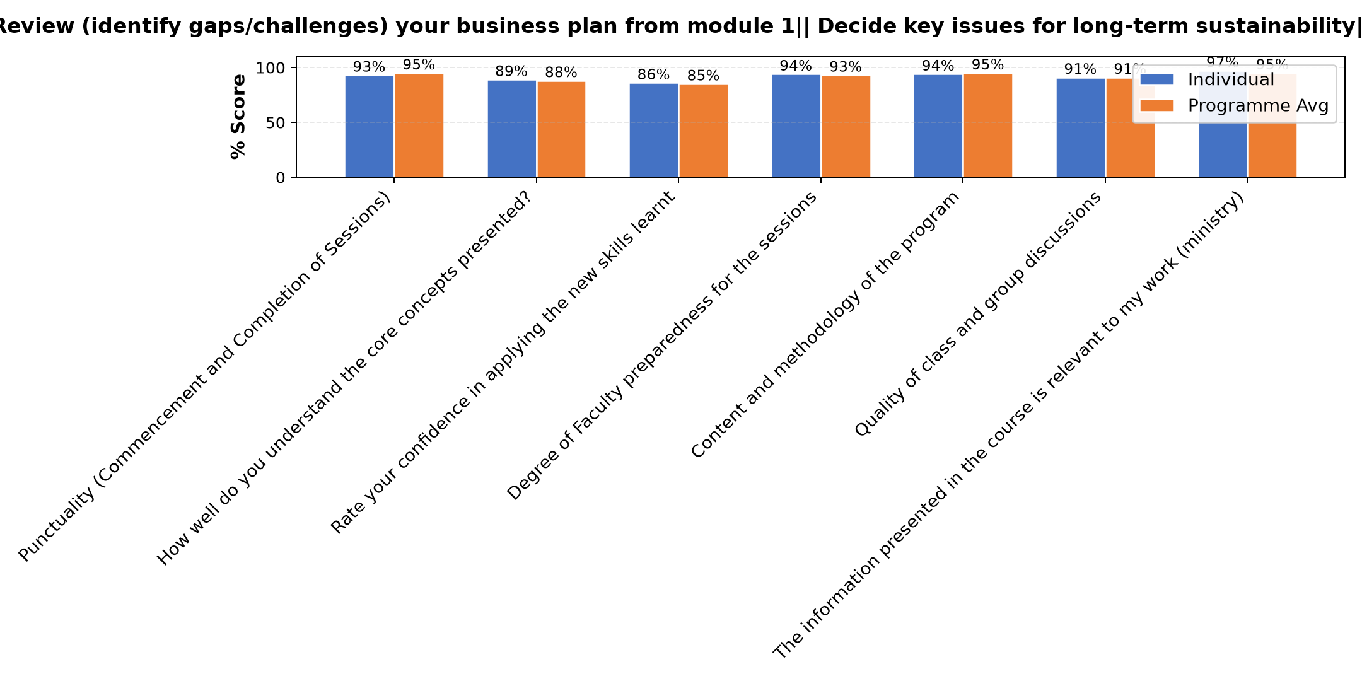

Comments & Feedback
- • Our Main challenge is finances
- • Some team members missed the session, it is draw back.
- • Today the Network system was not favourable
- • capital and funding
- • Finance for building and Transport
- • Financial barier
- • Inadequate Finances and slow response from contractor
- • Internet came a problem for me and malimo can not hear me
- • No barriers
- • I missed some information
SUBMITTED THROUGH:
SBS Evaluation Automation System

